**H1: Explore Travel Services in {City} – Cars, Drivers, Boats & Tours**

**Search Bar (Universal) like home page**

**Design:** [**https://us.trip.com/trains/?locale=en-US&curr=USD**](https://us.trip.com/trains/?locale=en-US&curr=USD) **light header with city background**

**H2: Why Book with MarHire in {City}?**

* ✅ Transparent prices, no hidden fees
* ✅ No deposit required on most listings
* ✅ Free delivery and flexible pickups
* ✅ Local verified partners only
* ✅ 24/7 multilingual support
* ✅ Instant booking + WhatsApp inquiry
* **Design:** [**https://us.trip.com/trains/?locale=en-US&curr=USD**](https://us.trip.com/trains/?locale=en-US&curr=USD) **Why Book Train Tickets With Trip.com? section**

**H2: Car Rental in {City} – Compare Deals with No Deposit**

Book a car rental in {City} with ease. Choose from economy hatchbacks, premium sedans, luxury SUVs, or 7-seaters.

**list of Car Rentals in {City}**

**Design:** [**https://www.booking.com/index.html?label=gen173nr-1fcaeoggi46adim1geaiwbiaebmaexuaexyaem2aeb6aeb-aeciaibqaidualjhqlcbsacadicjdrky2mzogrjlwm0zjqtndkyzi04mdbmlwqxotyzyjgzytgynngcbeacaq&sid=51dd6a09e204b311a0efdabdf52afb2b&aid=304142**](https://www.booking.com/index.html?label=gen173nr-1fcaeoggi46adim1geaiwbiaebmaexuaexyaem2aeb6aeb-aeciaibqaidualjhqlcbsacadicjdrky2mzogrjlwm0zjqtndkyzi04mdbmlwqxotyzyjgzytgynngcbeacaq&sid=51dd6a09e204b311a0efdabdf52afb2b&aid=304142) **Deals for the weekend section**

**H2: Private Driver in {City} – Chauffeur Services & Airport Transfers**  
Hire a bilingual private driver in {City} for city tours, full-day hire, or intercity transfers.

**list of Drivers in {City}**

**H2: Boat Rental in {City} – Cruises, Fishing Trips & Private Yachts**

Enjoy Morocco’s coastline with a private boat rental in {City}.

**list of Boats in {City}**

**H2: Things to Do in {City} – Local Tours & Unique Experiences**

Find the best things to do in {City}, from camel rides and quad tours to cultural classes and guided city walks.

**list of Activities in {City}**

**H2: Explore MarHire Services in Other Cities Across Morocco**

Planning to visit more than one destination? MarHire is available in multiple Moroccan cities

**list of all cities** [**https://www.booking.com/index.html?label=gen173nr-1fcaeoggi46adim1geaiwbiaebmaexuaexyaem2aeb6aeb-aeciaibqaidualjhqlcbsacadicjdrky2mzogrjlwm0zjqtndkyzi04mdbmlwqxotyzyjgzytgynngcbeacaq&sid=51dd6a09e204b311a0efdabdf52afb2b&aid=304142**](https://www.booking.com/index.html?label=gen173nr-1fcaeoggi46adim1geaiwbiaebmaexuaexyaem2aeb6aeb-aeciaibqaidualjhqlcbsacadicjdrky2mzogrjlwm0zjqtndkyzi04mdbmlwqxotyzyjgzytgynngcbeacaq&sid=51dd6a09e204b311a0efdabdf52afb2b&aid=304142) **explore Morocco section**

**Free SEO Text Block:**

**Design :** [**https://www.orbitz.com/Cars**](https://www.orbitz.com/Cars) 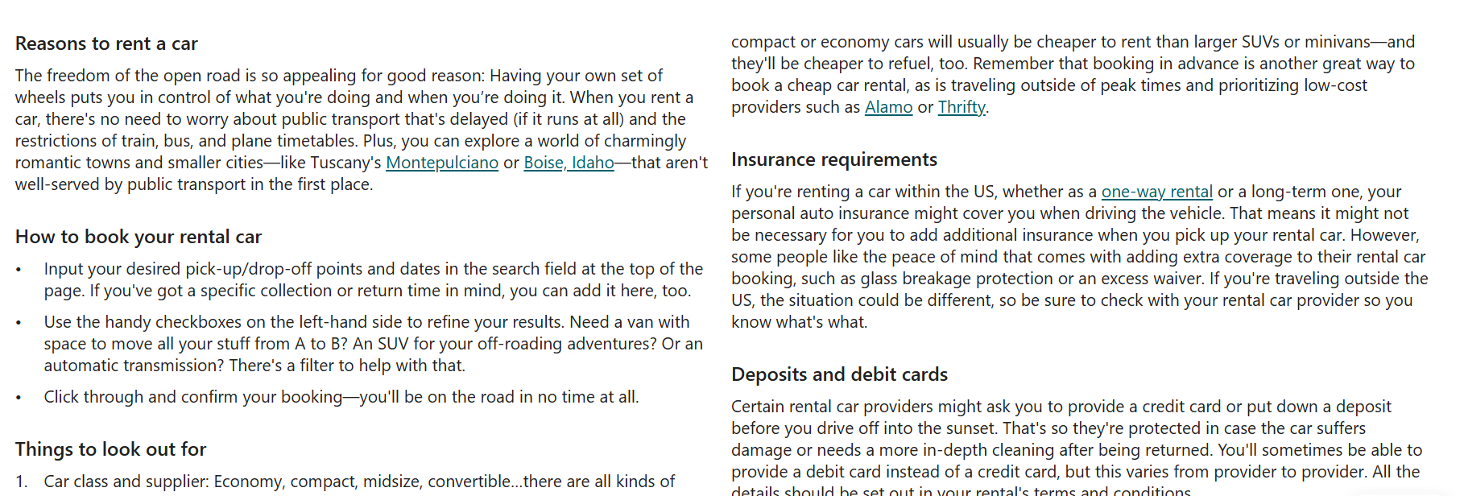

**H2: Frequently Asked Questions – Booking in {City}**

**How does MarHire work in {City}?**

MarHire is a local travel platform that allows you to compare and book car rentals, private drivers, boats, and activities in {City}. You choose the service, compare options, and book instantly — either online or via WhatsApp.

**Can I book a car, driver, or tour in advance?**

Yes, and we highly recommend it. Especially during holidays or high season in {City}, booking in advance guarantees better prices and availability — particularly for luxury vehicles or private tours.

**Is airport pickup available in {City}?**

Absolutely. Most of our services offer free delivery to/from {City} Airport, including car rentals and chauffeur services. You can specify your flight time and hotel details at checkout.

**What documents are required to rent a car in {City}?**

You’ll need:

A valid driver’s license

Your passport

(If needed) an international driving permit

A debit/credit card or cash (based on deposit policy)

**Is a deposit required for car rental or boat booking?**

Many of our car rentals require no deposit, especially for economy cars. For boats and drivers, it depends on the agency, but all policies are clearly stated. Use the “No Deposit” filter when searching.

**Can I contact the agency directly before booking?**

Yes. Every listing includes a WhatsApp contact with pre-filled messages so you can ask questions, confirm availability, or make special requests instantly.

**What is the cancellation policy?**

Most services allow free cancellation up to 48 hours in advance. You’ll see the cancellation terms clearly listed on each booking page.

**Can I pay by card or cash in {City}?**

Yes. Most partners accept both cash and card. Some offer pay-by-link options through WhatsApp for secure online payments.

**Do I need to speak French or Arabic?**

No our support and many agency staff speak English, and all listings are available in English. You’ll also find multilingual guides for activities and drivers.

**Design: same design of faq for other pages**

**SEO Metadata Template**

* **Meta Title:** {City} Travel Services | Car Rental, Drivers, Boats & Tours – MarHire
* **Meta Description:** Explore verified travel services in {City} with MarHire. Rent cars with no deposit, book private drivers, enjoy boat trips & tours. Transparent pricing, local experts.